**PASTERNAK, Boris (ПАСТЕРНАК, БОРИС) (1890-1960)**

Major Russian poet and writer. Pasternak was recognized as a leading, original poetic talent with the collection *My Sister Life* (written 1917, published 1922). *My Sister Life* is a celebration of the fecundity of nature, of love, artistic creation and the thrilling experience of revolutionary change. Beginning in the late 1920s Pasternak felt increasingly isolated and out of step with Soviet literary culture. After 1934 he focused his talents on literary translation, producing some of the finest translations of Shakespeare into Russian. In 1956 Pasternak completed his novel *Doctor Zhivago*, his long dreamed-of novel about an individual hero caught up in revolutionary Russia. Pasternak was awarded the Nobel Prize for Literature in 1958. An international scandal flared after he at first accepted the distinction and then gave in to Soviet pressure to refuse it with the words “Considering the meaning this award has been given in the society to which I belong, I must reject this undeserved prize which has been presented to me.” *Doctor Zhivago* was adapted as a major motion picture by director David Lean in 1965, and again by Giacomo Campiotti in 2002.

**Timeline of Life and Major Works**

**1890:** born in Moscow

**1909:** enters Moscow University as student of law

**1912:** studies philosophy at University of Marburg

**1914:** publication of *A Twin in Clouds* (Bliznets v tuchakh)

**1918:** publication of *Above the Barriers* (Poverkh bar’erov)

**1922:** publication of *My Sister Life* (Sestra moia - zhizn’), marriage to Evgeniia Lourie

**1923:** birth of first son Evgeny

**1924-31:** publication of epic poems *High Malady* (1924), *Lieutenant Schmidt* (1926), *The Year 1905* (1927) and *Spektorsky* (1931)

**1930:** first book publication of memoirs *A Safe Conduct* (Okhrannaia gramota)

**1934:** marriage to Zinaida Neugauz

**1938:** birth of second son Leonid

**1943:** publication of *On Early Trains* (Na rannikh poezdakh)

**1944:** publication of *Earth’s Vastness* (Zemnoi prostor)

**1957:** first publication of *Doctor Zhivago*, by Italian publisher Feltrinelli

**1958:** award and refusal of Nobel Prize for Literature

**1960:** death from cancer in Moscow

Pasternak was born into a talented intelligentsia family in Moscow, the 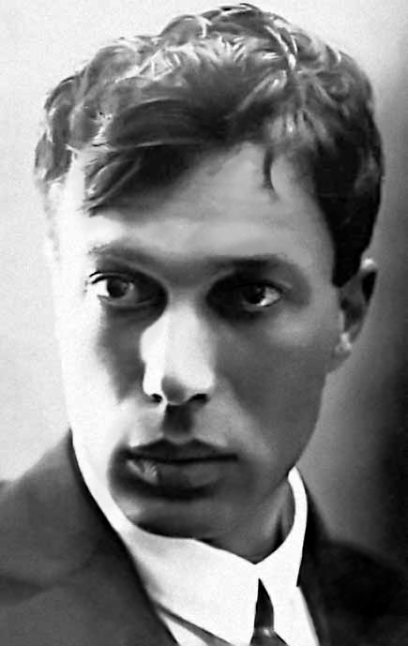son of a distinguished artist (Leonid Pasternak) and gifted pianist (Rozaliya Kaufman). The great writer Lev Tolstoy and extravagant Symbolist composer Alexander Scriabin, among other leading artistic figures, were frequent visitors to the family apartment. Pasternak himself was gifted in multiple artistic spheres and at first pursued a career as a concert pianist, which he discontinued because he did not have perfect pitch, as well as 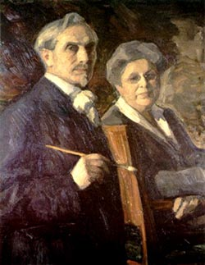graduate studies in Neo-Kantian philosophy at the University of Marburg in Germany.

**Pasternak in his twenties**

In 1914 he launched what would become a tumultuous four and a half decade career in letters with the poetry collection *A Twin in Clouds (Bliznets v tuchakh*), a book heavily influenced by Symbolism and its attendant focus on mysticism and other-worldly phenomena. As a young Symbolist poet he challenged the leading Futurist poet Vladimir Mayakovsky to a ‘poetic duel’. During this debate pitting the principles of Symbolism against those of dynamic, iconoclastic Futurism, Pasternak was won over by the larger-than-life Mayakovsky, resulting in his second, Futurist-influenced poetry collection *Over the Barriers* (*Poverkh bar’erov)* in 1916. Only with the collection *My Sister Life* (*Sestra moia zhizn’,* written 1917, published 1922 because of the Revolution) did Pasternak grow into his own authentic poetic voice and gain recognition as a leading, original talent. Written in the summer between the February and October Revolutions, *My Sister Life* is a celebration of the fecundity of nature, of love, artistic creation and the thrilling experience of revolutionary change. The unusual and refreshing poetic images of *My Sister Life* stem from what Michel Aucouturier has identified as a turn away from the usual poetic device of metaphor towards metonymy.

**Pasternak’s parents, a portrait by Leonid Pasternak**

**Pasternak (second from left) and Futurist colleagues including famous director Sergei Eisenstein (third from left) and Vladimir Mayakovsky (third from right)**

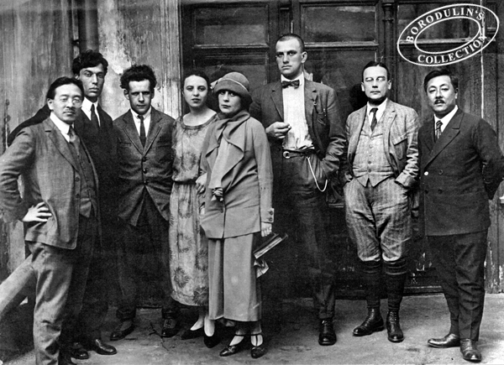Pasternak spent the 1920s attempting to capture the Revolution in epic poems like *High Malady* (*Vysokaia bolezn’,* 1924)*, Lieutenant Schmidt* (*Leitenant Shmidt,* 1927)*, The Year 1905* (*1905 god,* 1927) and *Spektorsky* (*Spektorskii,* 1924-31), but he was dissatisfied with these attempts, as well as with his prose efforts at the same objective. Stories such as *The Childhood of Luvers* (1922) attest to Pasternak’s talent for dazzling lyrical prose, while *The Story* (1929) marks the beginning of a long endeavor to describe a poetic young man caught up in the maelstrom of the Revolution, an effort that was finally completed with *Doctor Zhivago* thirty years later.

In 1926 Pasternak became part of a three-way poetic correspondence with the émigré poet Marina Tsvetaeva and the internationally renowned Austrian poet Rainer Maria Rilke. The poets shared a worldview that underlined the immortality of art and affirmed the importance of the individual, lyrical poetic point of view, a perspective that was under attack in the increasingly epic and collective-centered world of Soviet culture. In 1927 Pasternak officially resigned from the editorial board of Mayakovsky’s Futurist journal *Novy LEF*, in protest over the group’s new artistic platform to eradicate fictional modes of expression. Pasternak felt increasingly isolated and out of step with Soviet literary culture and after 1934 and the advent of socialist realism as the mandatory genre for publishing Russian writers, he focused his talents increasingly on literary translation, producing some of the finest translations of Shakespeare into Russian

In 1956 Pasternak completed *Doctor Zhivago*, his long dreamed-of novel about 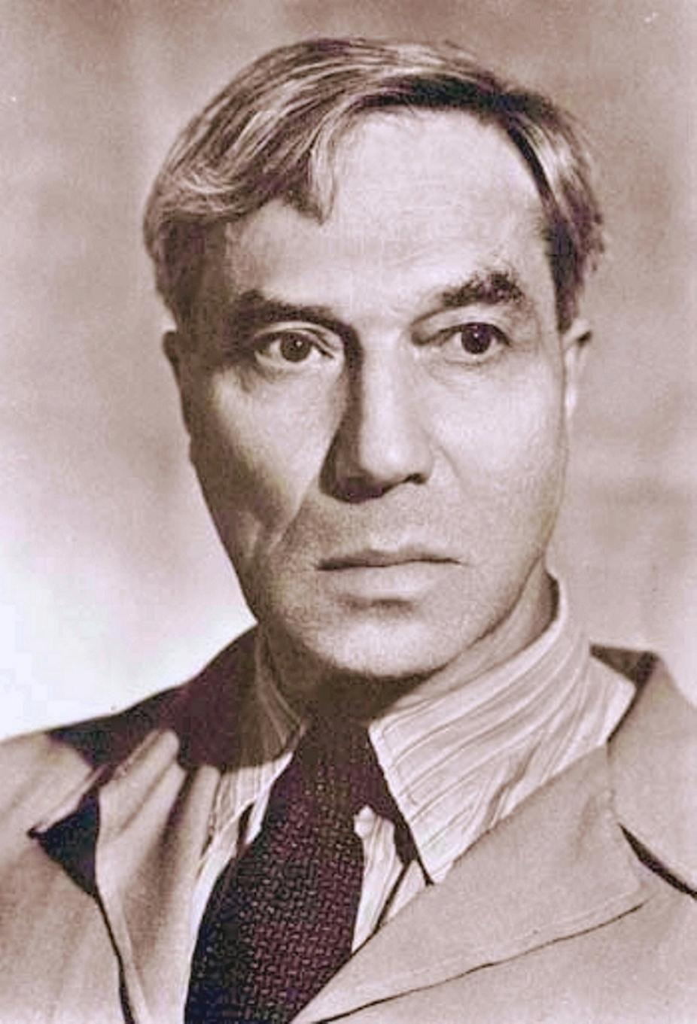an individual hero caught up in the Revolution. In the Thaw atmosphere following Nikita Krushchev’s so-called Secret Speech at the 20th Party Congress, in which he denounced Stalinism as a crime against the people, Pasternak was able to hope for the serial publication of his novel in the major state journal *Novy mir.* Publication was ultimately blocked at the highest level following a Central Committee decision calling the novel ‘a heinous calumny of the Revolution and of Soviet life.’ Subsequently *Doctor Zhivago* became the subject of an international scandal following its publication by Italian, French and British publishing houses in 1957 and 1958, at a time when foreign publication was considered illegal for a piece of Soviet literature deemed unpublishable by state organs. Pasternak was awarded the Nobel Prize for Literature in 1958 over fellow Soviet nominee Mikhail Sholokhov, a socialist realist writer and brother-in-law of Krushchev. The international scandal flared when Pasternak at first accepted the distinction and then refused it. Pasternak died of lung cancer in 1960. His oldest son Evgeny accepted the Nobel Prize posthumously on his behalf in 1989. *Doctor Zhivago* was adapted as a major motion picture by director David Lean in 1965, and again by Giacomo Campiotti in 2002. Along with a handful of poets including Anna Akhmatova, Alexander Blok, Osip Mandelstam and Marina Tsvetaeva, Pasternak is regarded as a leading Russian poet of the twentieth century.

**Through thousands of binoculars**

**The night of darkness stares at me.**

**If possible, O Abba, Father,**

**Then take this cup away from me.**

**I love thy stern design, and I am**

**Content to act this role of woe.**

**But there’s another play on stage;**

**Then spare me now and let me go.**

**From “Hamlet”, one of the poems of *Doctor Zhivago***

**Translation Eugene M. Kayden**

**Pasternak in his sixties**

**Chronology of Major Works**

POETRY

*Bliznets v tuchakh* (A Twin in Clouds). Moscow, 1914.

*Poverkh bar’erov* (Above the Barriers). Moscow: Tsentrifuga, 1916.

*Sestra moia – zhizn’* (My Sister Life). Moscow: Izdatel’stvo Z.I. Grzhebina, 1922.

PROSE

*Detstvo Luvers* (The Childhood of Luvers) in *Nashi dni*, No. 1, 1922.

*Okhrannaia gramota* (A Safe Conduct), Part I, in *Zvezda*, No. 8, 1929, Parts II and III in *Krasnaia nov’*, No. 4, 1931 and Nos. 5-6, 1931.

*Doktor Zhivago* (Doctor Zhivago), first published in Italian translation in Milan, 1957. First published in Soviet Union in journal *Novyi mir,* 1988.

**References and Further Reading**

Aucouturier, Michel. (1978) “The Metonymous Hero or the Beginnings of Pasternak the Novelist” in Victor Erlich, ed. *Pasternak, A Collection of Critical Essays.* Englewood Cliffs, NJ: Prentice-Hall.

Here is the essay in which Pasternak’s mastery of metonymy (see entry above) is discussed.

Barnes, Christopher (1989 and 1998) *Boris Pasternak, A Literary Biography v. 1 1890-1928, v. 2 1828-1960.* Cambridge: Cambridge University Press.

The definitive biography of Pasternak, aptly called a literary biography because of its valuable literary insights, by a highly-regarded academic specialist. Very detailed but highly readable.

O’Connor, Katherine Tiernan. (1988) *Pasternak’s My Sister Life: The Illusion of Narrative.* Ann Arbor, MI: Ardis.

A fascinating analysis of Pasternak’s most famous collection of poetry as having a novelistic form.

Rudova, Larissa. (1987) *Understanding Boris Pasternak.* Columbia, SC: University of South Carolina Press.

A good, well-written overview and analysis of Pasternak’s poetry and prose. A great place to start for undergraduates.

Tsvetaeva, Marina (trans. 1992) “A Downpour of Light” in Angela Livingston trans. *Art in the Light of Conscience. Eight Essays on Poetry by Marina Tsvetaeva.* Cambridge, MA: Harvard University Press.

This essay by Pasternak’s contemporary and fellow poet is one of the most insightful about Pasternak’s poetry.

Megan Swift

University of Victoria

Source URLs for images

Figure 1. http://theanatomyofmelancholy.tumblr.com/post/648300480/russian-writer-boris-pasternak-died-may-30-1960

Figure 2. <http://en.wikipedia.org/wiki/Boris_Pasternak>

Figure 3. <http://en.wikipedia.org/wiki/Boris_Pasternak>

Figure 4. http://02varvara.wordpress.com/2009/01/page/2/